**MODERN SOFTWARE ENGINEERING-CS 790**

**PROJECT MILESTONE-3**

**TEAM 3**

VINAY KUMAR REDDY KANDULA

BATCHANGARI ROHITH CHANDRA GOUD

BHARGAV VECHA

**PROJECT NAME:** PRIVATE CHAT BOX

**Architectural Design**

The following diagram shows the Client Server architecture between clients and server. Clients using application interface communicate with the server.

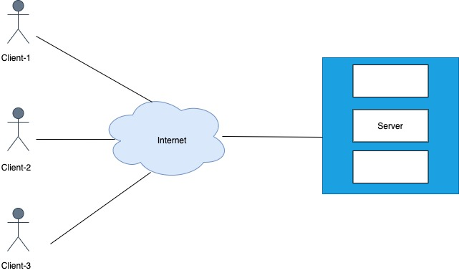

**Use-Case Scenario**

Scenario-1:

The user tries to enter the key to enter into the chat room. The key entered by the user is validated by the server. If the key exists in the server, the user is directed to the chat room or else the user is warned as an incorrect key.

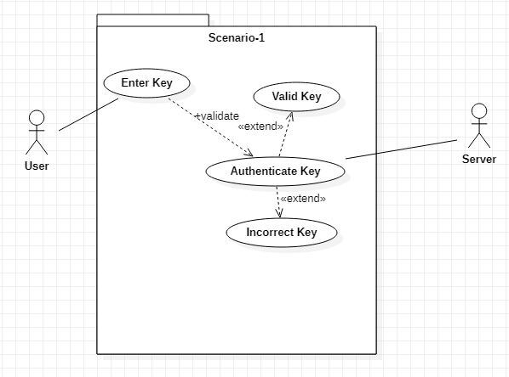

Scenario-2:

When a user wants to create a new chat room, he clicks on the generated key. A key will be generated and stored in the server. When other users enter the same key, it is verified in the server and they enter the chat room.

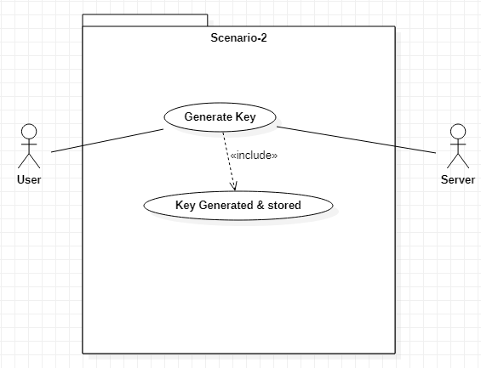

Scenario-3:

When the users enter the chat room, they can type their messages in the text area and send the message in the room. Whoever is present in the chat room, they will be able to see the message sent by a user. The users can also communicate using emojis.

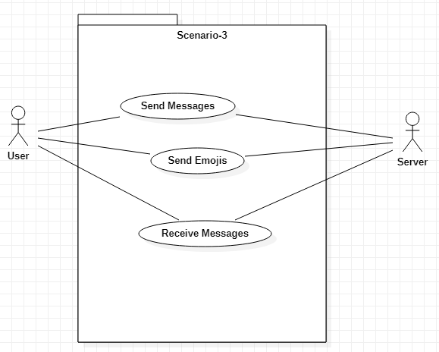

Scenario-4:

When all the users exit the chat room, the chat is cleared from the server.

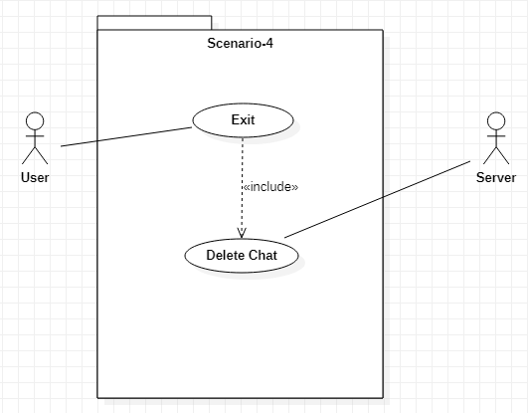

**Sequence Diagram**

The following figure shows the Sequence diagram of users, application and Database. Users enter the login information in Application the Application checks the details in the database if the chat room id matches then the user is allowed into the chat room. once the users leave the chat room then the messages are deleted automatically.

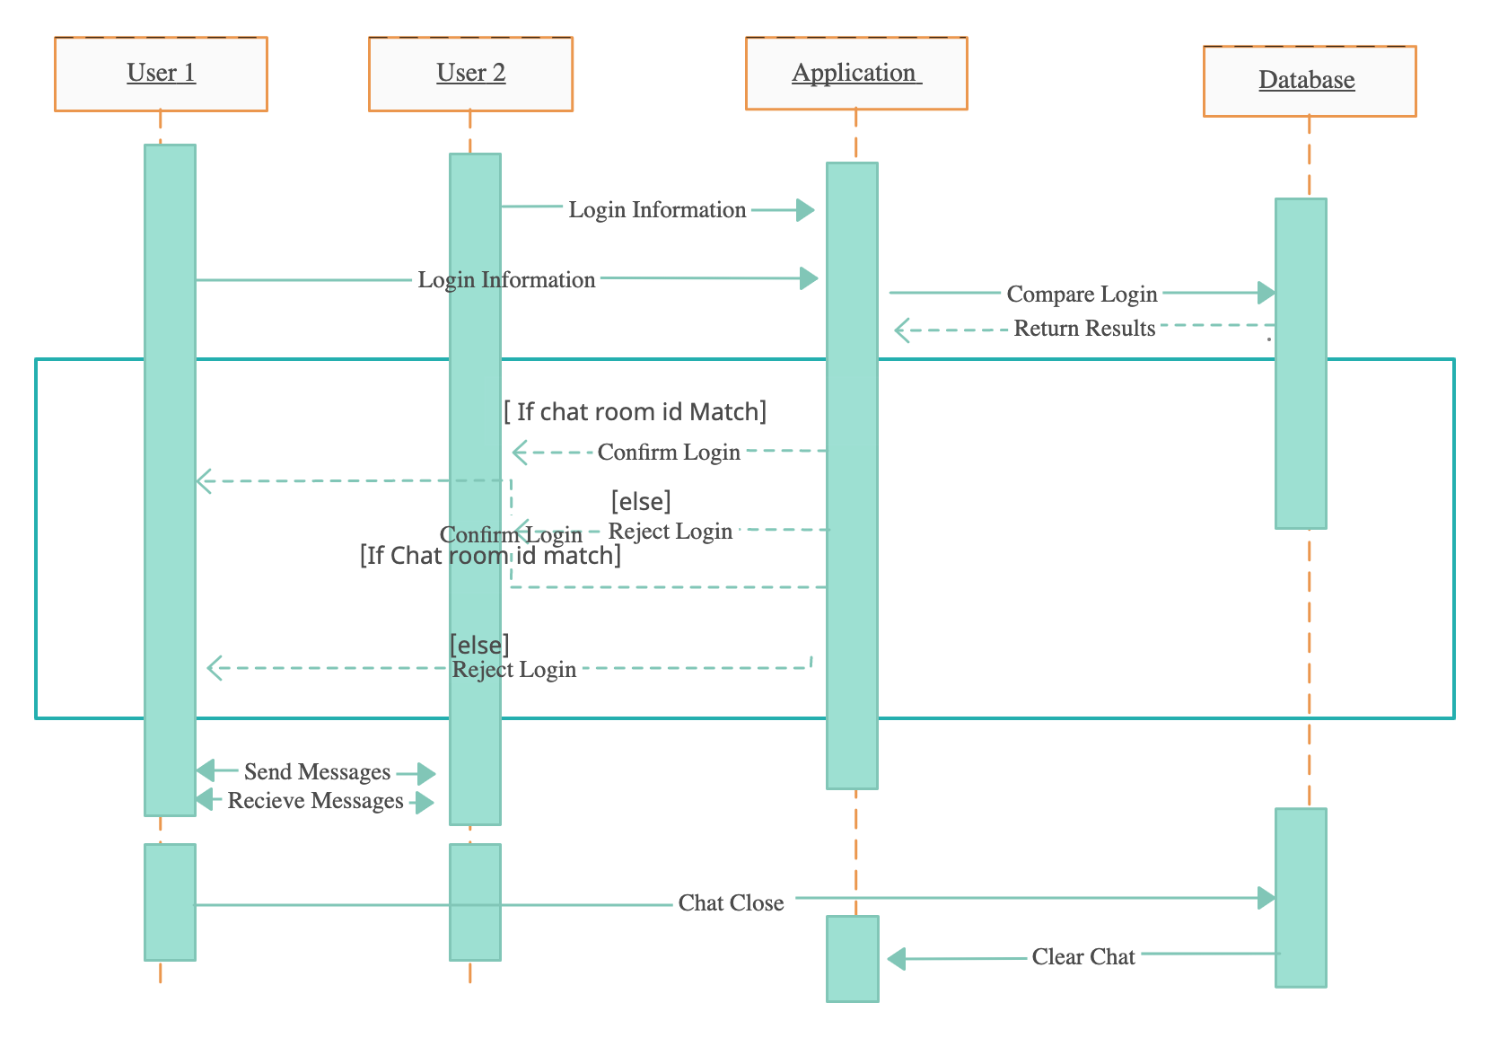

**Class Diagram**

In the Class diagram there are 4 different classes User, Key, Chat Room and Server. The following diagram shows the relation between classes.

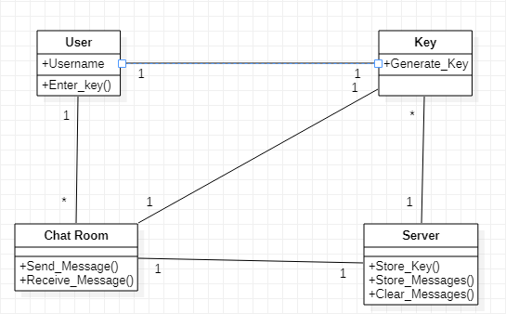

**Relational Database Design**

The following diagram shows the Relationship design of the database

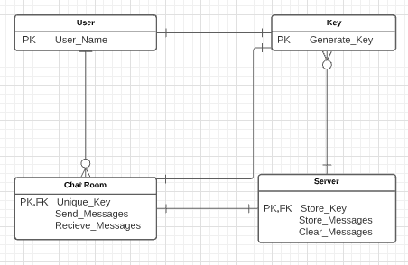

**User- Interface Design**

* First User enters chat screen and enters name and chat room id



* The Users get into chat screen and once the user leave the chat room then all the messages get deleted automatically.

